REPORT ON INDUCTION PROGRAMME FOR FIRST SEMESTER STUDENTS
Date: 31st August 2026
The Dean’s Office of Sikkim Government College, Burtuk organised an Induction Programme for the First Semester students admitted under NEP 2020 on 31st August 2026. The programme aimed to warmly welcome the newly admitted students and familiarise them with the academic, administrative and co-curricular environment of the college.
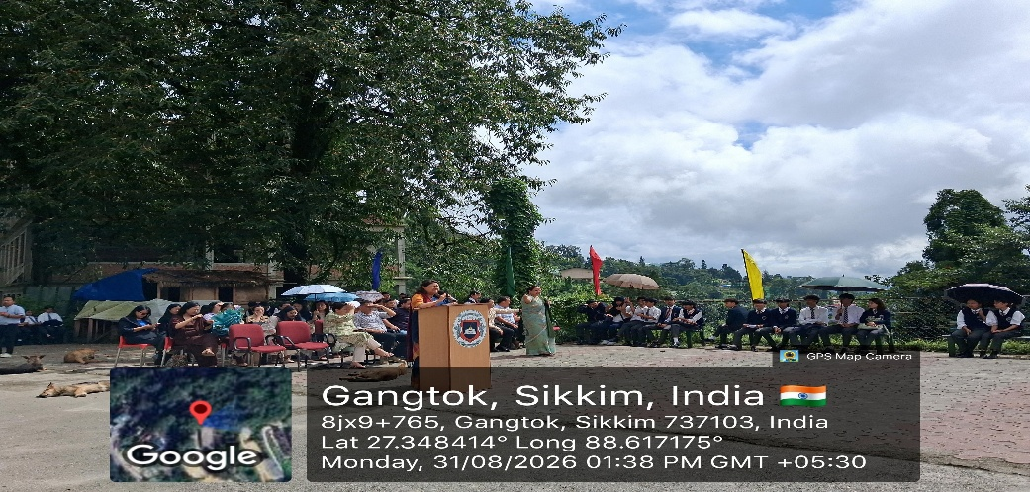

The programme commenced with an address by the Principal, followed by briefings from the Deans and Convenors of various committees, including the Examination, Admission, Discipline, NCC, NSS, Culture and Sports Committees. The respective Convenors briefed the students about the roles, responsibilities, procedures and facilities associated with their committees.

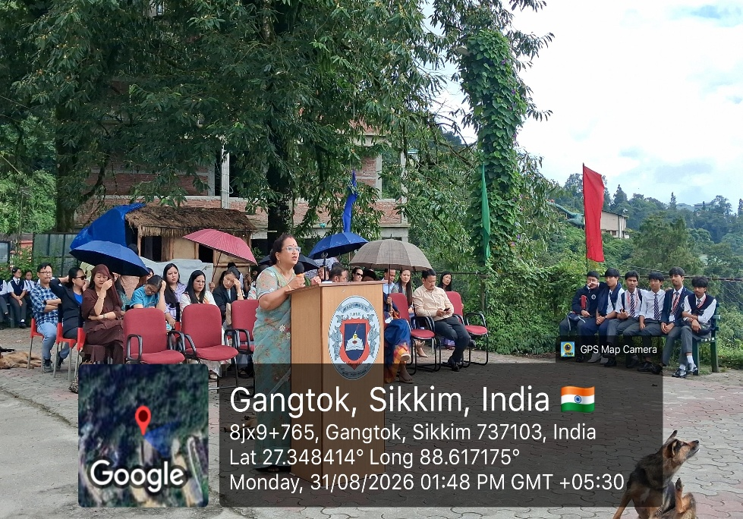
The Heads of the respective Departments introduced their departments and fellow faculty The Heads of the respective Departments introduced their departments and fellow faculty members, helping the students become familiar with their teachers and academic programmes.
members, helping the students become familiar with their teachers and academic programmes.
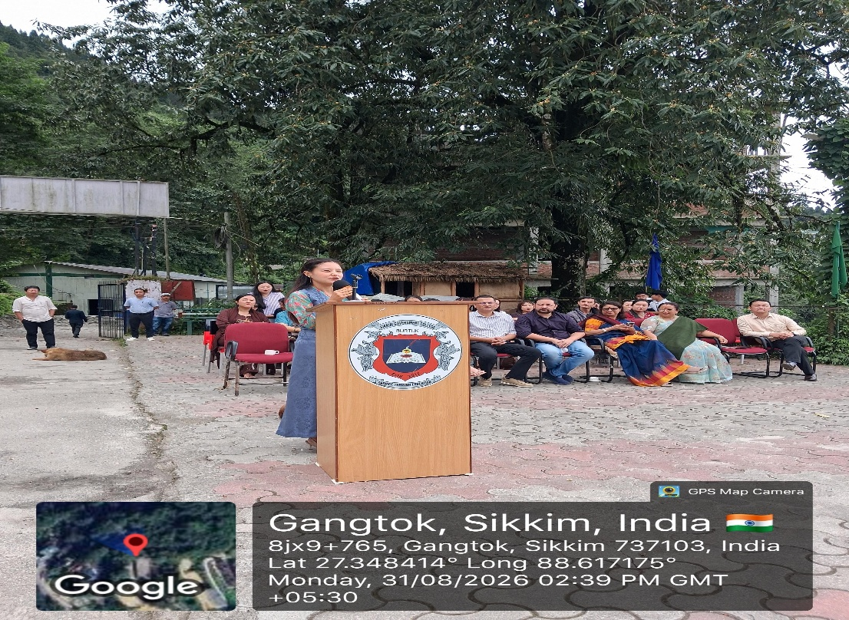

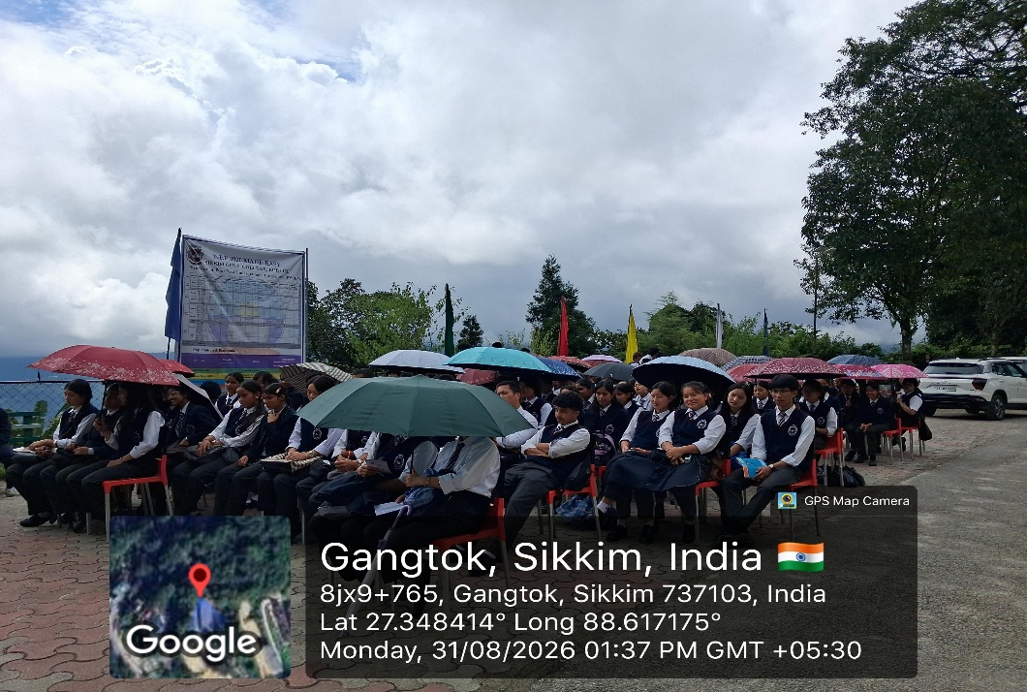
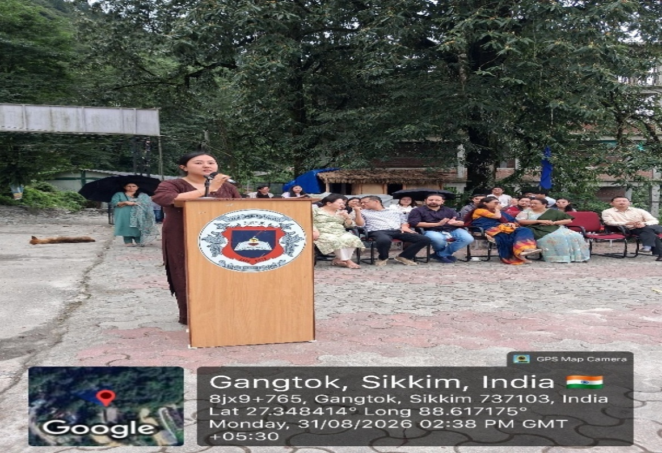
An interactive session between teachers and students was also conducted, providing an The students were also made aware of the rules and regulations of the college, prescribed dress code, and the importance of maintaining discipline and decorum within the campus premises. They were specifically briefed about the Anti-Ragging provisions and the Mobile-Free Zone policy of the college.

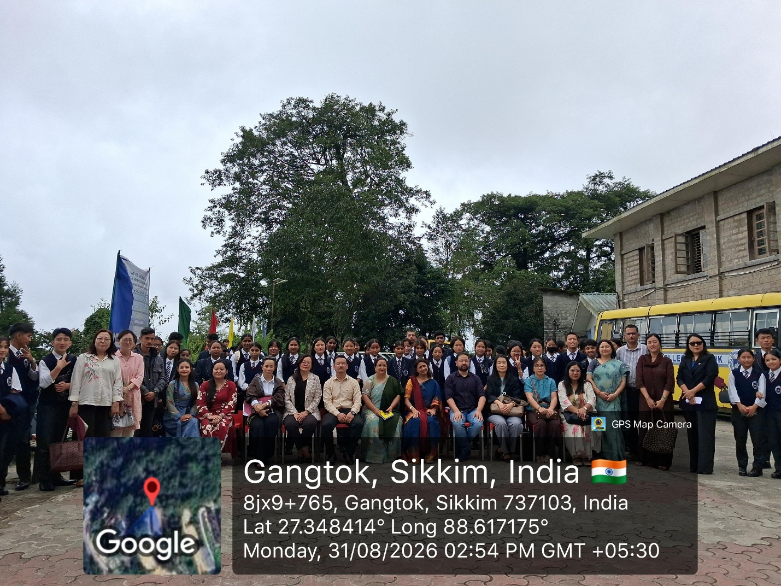
The induction programme was successfully conducted and provided the newly admitted students with a clear understanding of the academic, administrative, disciplinary and co-curricular framework of the college. It encouraged them to begin their college journey with confidence, responsibility and enthusiasm.

